INTRODUCTION
UCUCI Bank is one of the India’s front line private sector banks, offers a diverse range of retail lending products to millions of customers. As the bank's loan portfolio continues to expand, understanding borrower repayment behaviour has become increasingly important for managing credit risk and maintaining portfolio health. High default rates and inefficient risk pricing can negatively impact profitability, and sustainable growth.
This study aims to analyse loan performance data to identify the key factors influencing borrower repayment outcomes and the overall Loan Repayment Rate (LRR). By examining borrower financial profiles, credit history, loan characteristics, and risk grades, the analysis seeks to uncover patterns associated with successful repayment and default risk.

PROBLEM STATEMENT
As UCUCI Bank's loan portfolio continues to grow, effectively managing credit risk and improving repayment performance have become critical business priorities. Variations in borrower financial profiles, credit history, loan terms, and risk grades can significantly influence repayment outcomes, leading to defaults and reduced portfolio profitability. This project aims to analyse loan performance data to identify the factors that impact the Loan Repayment Rate (LRR), uncover high-risk borrower segments, and evaluate the effectiveness of the bank's risk-based pricing strategy.

ANALYSIS APPROACH
- Understand the Business Problem: Define the primary objective of improving Loan Repayment Rate (LRR) and review the dataset to identify variables relevant to loan performance and credit risk.
- Define Key Metrics and Hypotheses: Establish the primary KPI (Loan Repayment Rate) and supporting KPIs such as “Default Rate”, “Recovery Rate”, and “Average Interest Rate” by Grade. Formulate hypotheses around borrower characteristics, loan features, and credit history factors that may influence repayment outcomes.
- Data Quality Assessment and Cleaning: Inspect the dataset structure, data types, missing values, duplicate records, and inconsistencies. Clean and preprocess the data by handling missing values, correcting data formats, and preparing variables for analysis.
- Feature Engineering and Data Preparation: Create derived variables where necessary, convert date and categorical fields into analysable formats, and prepare the dataset for effective comparison and aggregation.
- Portfolio Overview Analysis: Evaluate the overall health of the loan portfolio by analysing total loans issued, funded amounts, repayment amounts, loan status distribution, Loan Repayment Rate (LRR), and Default Rate.
- Loan Repayment Rate Driver Analysis: Examine how LRR varies across loan grades, sub-grades, loan terms, interest rates, loan purposes, and other loan characteristics to identify the key drivers of repayment performance.
- Default Risk Analysis: Analyse charged-off loans and default rates across different borrower and loan segments to identify factors associated with increased default risk.
- Borrower Risk Profiling: Investigate the relationship between borrower financial profiles, debt-to-income ratio, annual income, employment history, and credit behaviour to identify high-risk and low-risk borrower segments.
- Recovery Performance Analysis: Evaluate recovery rates on defaulted loans and assess which borrower and loan segments contribute to stronger or weaker post-default recoveries.
- Hypothesis Testing and Relationship Analysis: Test the predefined hypotheses and analyse relationships between key variables and repayment outcomes to validate findings and uncover meaningful patterns.
- Visualization and Insight Generation: Develop appropriate visualizations to communicate trends, comparisons, and relationships effectively, ensuring findings are clear and actionable for stakeholders.
- Recommendations and Business Impact: Summarize key findings and provide data-driven recommendations to improve Loan Repayment Rate (LRR), optimize risk-based pricing, reduce default risk, and support sustainable portfolio growth.

DATASET
This dataset contains loan-level information from UCUCI Bank's retail lending portfolio, including borrower profiles, credit history, loan characteristics, and repayment outcomes. Key variables include loan amount, interest rate, loan term, risk grade, annual income, debt-to-income ratio, credit utilization, and loan status. Using Python and Tableau, this dataset can be analysed to identify repayment trends, evaluate risk factors, and generate actionable insights to improve the Loan Repayment Rate (LRR), reduce defaults, and support better lending decisions.

KEY METRICS AND HYPOTHESES

KPI TREE
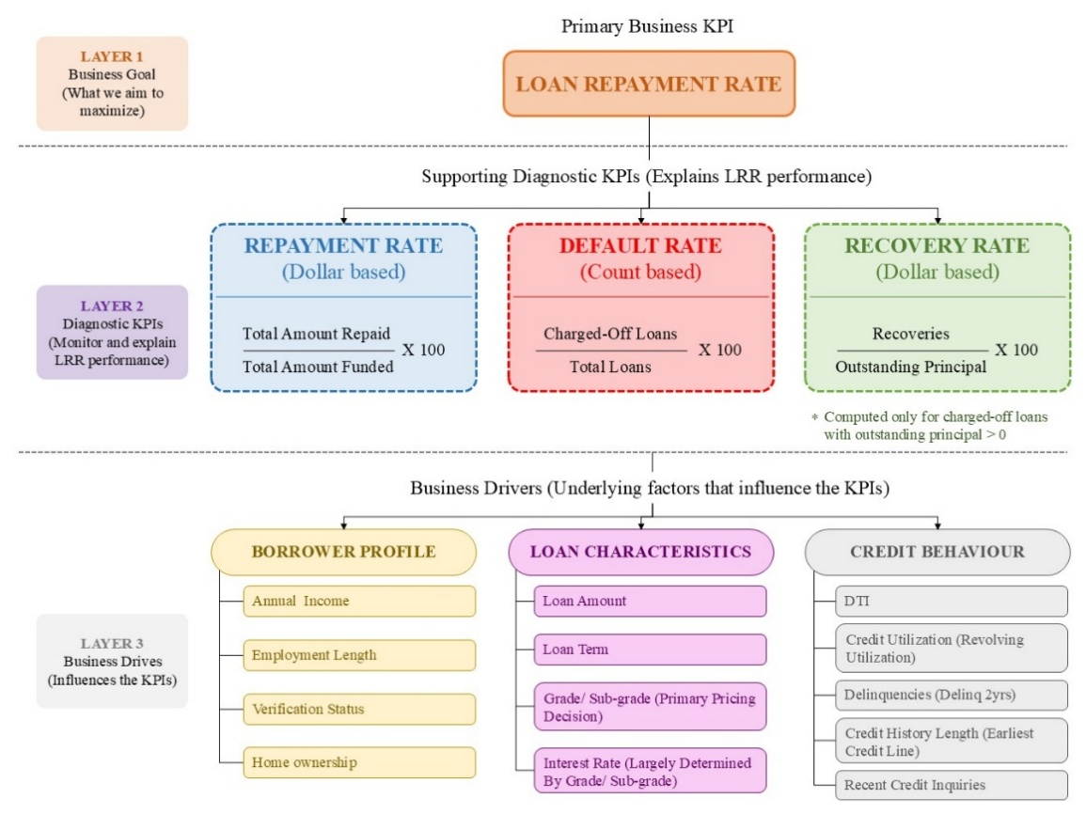
Default Rate is loan-count based and not a component of LRR.
Indicates analytical relationship/ influence
Indicates KPI grouping (not mathematical aggregation)
This analysis is centred around Loan Repayment Rate (LRR) as the primary business KPI. LRR measures the proportion of funded loan amounts that are successfully recovered from borrowers and serves as a key indicator of portfolio performance and credit risk management effectiveness.
To better understand the factors influencing LRR, three supporting diagnostic KPIs are considered:
- Repayment Rate measures the percentage of funded loan amounts that have been repaid by borrowers and provides direct insight into repayment performance.
- Default Rate measures the proportion of loans that have been charged off, helping identify the extent of credit losses within the portfolio.
- Recovery Rate evaluates the effectiveness of post-default recovery efforts by measuring the amount recovered from defaulted loans relative to the outstanding principal.
The analysis further examines the underlying business drivers influencing these KPIs. These drivers are grouped into three key categories:
- Borrower Profile – including annual income, employment length, and verification status.
- Loan Characteristics – including loan amount, loan term, grade/sub-grade, and interest rate.
- Credit Behaviour – including debt-to-income ratio (DTI), credit utilization, delinquency history, and credit history length.

HYPOTHESES

Loan Characteristics Hypotheses
- H1: Higher-risk loan grades exhibit disproportionately higher default rates relative to the increase in interest rates, indicating potential inefficiencies in risk-based pricing.
- H2: Longer loan terms are associated with higher default rates, and this relationship persists across multiple loan grades.
- H3: Loan repayment performance varies significantly across loan purposes, indicating that certain borrowing intents carry higher repayment risk than others.

Borrower Profile Hypotheses
- H4: Borrowers with higher Debt-to-Income (DTI) ratios exhibit higher default rates, although the relationship may vary across DTI segments.
- H5: Income verification status is associated with repayment outcomes, but verified borrowers may not necessarily exhibit lower default rates than non-verified borrowers.
- H6: Home ownership status influences repayment performance, with renters expected to exhibit higher default rates than homeowners and mortgage holders.

Credit Behaviour Hypotheses
- H7: Borrowers with higher revolving credit utilization exhibit higher default rates, although the relationship may not be strictly linear across utilization levels.
- H8: Borrowers with a higher number of recent credit inquiries (inq_last_6mths) exhibit higher default rates than borrowers with fewer inquiries.
- H9: Borrowers with longer credit histories exhibit lower default rates and stronger repayment performance than borrowers with shorter credit histories.

KPI Validation Hypothesis
- H10: The Recovery Rate metric may not be computable for a significant portion of charged-off loans because outstanding principal balances are already zero at the time of observation.

DATA CLEANING AND PREPARATION
Data cleaning and preparation are crucial in ensuring the dataset is accurate, consistent, and suitable for meaningful analysis. Before performing exploratory data analysis and testing the hypotheses, the dataset must be carefully examined for missing values, duplicate records, inconsistent formats, incorrect data types, and other data quality issues.
Several variables require transformation and feature engineering to support the analysis objectives. This includes creating borrower segments, deriving credit history length, generating risk indicators, and preparing variables for KPI calculations such as Loan Repayment Rate (LRR), Default Rate, and Recovery Rate.
The following section outlines the step-by-step data cleaning and preparation process performed to create an analysis-ready dataset.

Step 1: Dataset Exploration and Overview
The first step in the data cleaning process involves understanding the structure, quality, and characteristics of the loan dataset. This is achieved by examining the dataset dimensions, column information, data types, missing values, and summary statistics.
The dataset exploration focuses on the following aspects:
- Dataset dimensions: Determine the total number of rows and columns present in the dataset.
- Data types: Identify whether variables are stored as numerical, categorical, or date-related fields.
- Non-null and null values: Evaluate the completeness of each column by examining missing value counts and percentages.
- Statistical summaries: Generate descriptive statistics for numerical variables to understand their distribution, central tendency, and range.
This step helps identify potential issues such as:
- Columns such as “annual inc joint”, “dti joint”, “verification status joint”, “mths since last record” have more than 80% of missing values. Which may require removal.
- Variables stored in incorrect formats, such as dates stored as text or percentage fields stored as strings.
- High-cardinality categorical variables that may not be suitable for direct analysis.
- Numerical variables with unusually large ranges that may require further investigation during outlier analysis.
Additionally, descriptive statistics are generated for key financial variables such as loan amount, annual income, debt-to-income ratio (DTI), interest rate, revolving utilization, and instalment amount. This provides an initial understanding of borrower characteristics, loan structures, and repayment-related attributes before proceeding with data cleaning and preprocessing.

Step 2: Handling Missing Values
Missing values were examined to determine whether they represented true data quality issues or meaningful business information.
- Columns with extremely high missing percentages (greater than 80%) and limited analytical value, such as “annual inc joint”, “dti joint”, “verification status joint”, “desc”, and “mths since last record”, were removed from the dataset.
- Missing values in revolving utilization (revol_util) were replaced using the median value to minimize the influence of outliers.
Certain variables required special treatment because missing values carried business meaning rather than representing absent information.
- For example, missing values in “mths since last delinq” and “mths since last major derog” were interpreted as borrowers having no prior delinquency or major derogatory records and were therefore replaced with a flag value of -1.
- Missing values in “next pymnt d” were retained because loans that are fully paid or charged off naturally do not have a future payment date.
- Analysis of the “next_pymnt_d” variable revealed that all missing values are concentrated within loans that have a status of Fully Paid or Charged Off. In contrast, active loan statuses such as Current, Issued, Late, and In Grace Period consistently contain valid next payment dates. This confirms that the missing values are driven by business logic. So no imputation was performed and the null values were retained.

Step 3: CONVERTING DATA TYPES
Variables stored in inappropriate formats can lead to incorrect calculations, grouping errors, and inefficient data processing.
- All date-related variables, including issue date (issue d), earliest credit line (earliest cr line), last payment date (last pymnt d), next payment date (next pymnt d), and last credit pull date (last credit pull d), were converted from object type to datetime format.
- Categorical variables such as grade, sub grade, home ownership, verification status, and loan status were retained in their original object format.

Step 5: GROUPING HOME OWNERSHIP CATEGORIES
The categories “ANY” and “NONE” represent a very small proportion of the dataset and do not describe distinct borrower groups for repayment analysis.
To improve interpretability, these categories were consolidated into the broader “OTHER” category, while the major categories (RENT, OWN, and MORTGAGE) were unchanged.

Step 6: FEATURE ENGINEERING LOAN STATUS COLUMN
To simplify repayment analysis while preserving the original loan information, two additional business-oriented variables were created from the “loan status” column.
- The first variable, “loan status clean”, groups detailed loan statuses into broader repayment stages such as Fully Paid, Current, Late – Early, Late – Severe, Default, and Charged Off. This grouping provides a clearer representation of the loan lifecycle and enables more meaningful comparisons.
- The second variable, “meets credit policy”, identifies whether a loan satisfied the bank's credit policy at the time of issuance. Loans with statuses prefixed by "Does not meet the credit policy" were assigned a value of No, while all remaining loans were assigned Yes. This feature enables additional analysis to evaluate whether loans issued outside the standard credit policy exhibit different repayment patterns.
- The major categorical variables (grade, sub grade, verification status, and purpose) were found to be consistent and required no standardization.

Step 7: OUTLIER ANALYSIS
Outlier analysis was performed on key numerical variables using the Interquartile Range (IQR) method and further validated through boxplot visualizations.
- variables such as “annual inc”, “revol bal, received “total rec prncp”, “total rec int”, and “last pymnt amnt” contain a relatively higher proportion of potential outliers. The boxplots also indicate that these variables exhibit strong right-skewed distributions, with a small number of borrowers having exceptionally high values.
- On the other hand, variables such as “loan amnt”, “dti”, “revol util”, and “int rate” show comparatively fewer outliers and remain within expected business ranges.
Since the identified outliers correspond to legitimate borrower characteristics and loan repayment behaviours rather than data entry errors, no observations were removed or transformed.
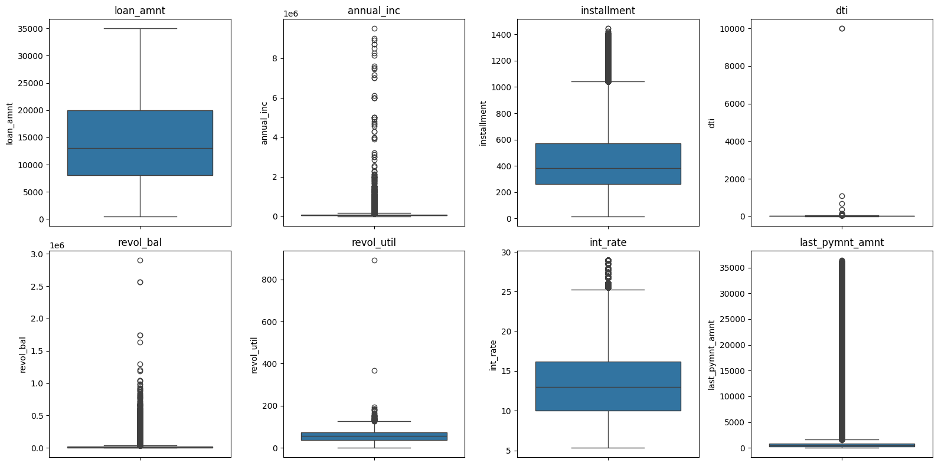
Figure 1 Boxplot of potential variables

Step 8: STRUCTURAL ZERO ANALYSIS
Structural zero analysis was conducted to distinguish legitimate zero values from missing or erroneous observations.
- Variables including “out prncp”, “recoveries”, “collection recovery fee”, and “total rec late fee” contain a high proportion of zero values due to the natural loan repayment lifecycle.
- For example, zero outstanding principal indicates that a loan has been fully repaid or charged off, while zero recoveries and recovery fees are expected for loans that never entered the recovery process. Similarly, zero late fees indicate borrowers who did not incur payment delays.
- Since these zero values represent valid business outcomes, no transformation or removal was performed.

Step 9: FINAL REVIEW AND EXPORT
After completing all data cleaning and preprocessing steps, the dataset is subjected to a final quality review to ensure its consistency, completeness, and readiness for analysis.
- Verification of remaining missing values to ensure that only business-meaningful null values are retained and no critical information is missing.
- Duplicate record validation to confirm that each observation represents a unique loan.
- Inspection of the final dataset structure and data types to verify that all variables are stored in appropriate formats for analysis and visualization.
Finally, the cleaned dataset is exported as a CSV file, creating a single source for exploratory data analysis, KPI calculation, hypothesis testing, and Tableau dashboard development.

EXPLORATORY DATA ANALYSIS (EDA)
Exploratory Data Analysis (EDA) is performed to understand the overall characteristics of the loan portfolio, identify repayment patterns, and evaluate the key factors influencing Loan Repayment Rate (LRR). EDA helps validate business hypotheses, uncover hidden trends, and generate actionable insights that support risk management and lending decisions.

Phase 1: Business Feature Engineering & KPI Derivation
To facilitate business-oriented analysis, several derived variables were created from the cleaned dataset.
- “credit history yrs”, was generated from the borrower's earliest credit line to quantify credit history length in years.
- Loan Repayment Rate (LRR) was calculated for each loan as the ratio of total amount repaid to the funded amount
- A binary “is default” indicator was created to simplify default analysis and subsequent hypothesis testing.
The analysis shows:
- An average Loan Repayment Rate of 53.91%, indicating that, on average, just over half of the funded amount has been recovered across all loans in the portfolio.
- The overall Default Rate 5.18%, suggest that a relatively small proportion of loans have reached a charged-off status.
- Borrowers have an average credit history of 25.84 years, reflecting a mature lending portfolio with established credit profiles.
- No loans satisfied the conditions required to compute Recovery Rate (charged-off loans with positive outstanding principal), indicating that recovery analysis is not applicable for the current dataset and will be excluded from subsequent analysis.

Phase 2: Executive KPI Dashboard
The Executive KPI Dashboard provides a high-level overview of the loan portfolio by summarizing the bank's key performance indicators.
- The loan portfolio is predominantly composed of Current loans (71.1%), indicating that most borrowers are still actively repaying their loans.
- The overall Default Rate remains relatively low (5.2%), suggesting satisfactory portfolio quality.
- The overall Loan Repayment Rate of 51.3% reflects the fact that a significant proportion of loans are still outstanding rather than indicating poor repayment performance.
- Loans in Late and Default stages account for a relatively small share of the portfolio, but these segments represent potential future credit risk and should be monitored closely.
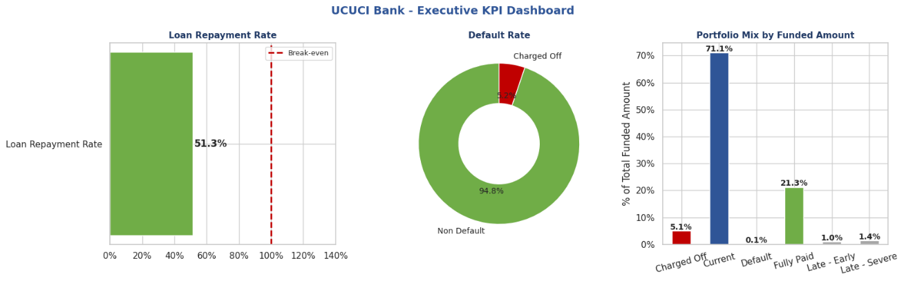

Actionable Insights
- Although the Charged Off portfolio is relatively small (5.1%), targeted interventions for Late – Early and Late – Severe borrowers could prevent additional loans from progressing into charge-off status.
- The dashboard establishes a performance baseline for the subsequent phases, where borrower characteristics, loan attributes, and credit behaviour will be analysed to identify the primary drivers influencing repayment performance and default risk.

Phase 3: LRR MECE Decomposition
This phase validates the KPI tree by decomposing the overall Loan Repayment Rate (LRR) into the contributions of each loan status category. Each contribution is calculated as the product of the portfolio weight and the repayment ratio of that category, ensuring that every loan is counted exactly once (Mutually Exclusive) and that all loan statuses collectively explain the overall portfolio performance (Collectively Exhaustive).
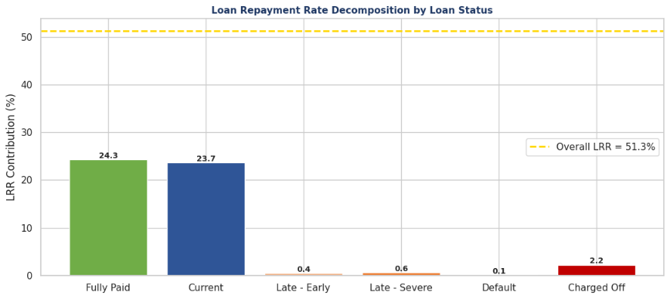
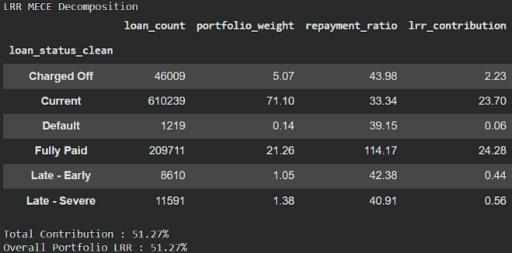
Analysis result
Key Findings
- The LRR decomposition is mathematically valid, with individual loan status contributions summing exactly to the overall portfolio LRR (51.27%).
- Fully Paid loans (21.26%) contribute the most to LRR (24.28 pts) due to complete principal and interest recovery.
- Current loans (71.10%) contribute 23.70 pts, indicating significant repayment potential as they mature.
- Late, Default, and Charged Off loans contribute minimally but represent the primary sources of repayment risk.
Actionable Insights
- Prioritize Current loans, as improving their transition to Fully Paid status will have the greatest impact on overall LRR.
- Implement early collection strategies for Late and Default borrowers to prevent progression into Charged Off status.
- Strengthen underwriting and risk monitoring to reduce Charged Off loans and improve long-term portfolio profitability.

Phase 4: Univariate Analysis – Continuous Variables
Univariate analysis is the simplest form of statistical analysis where data contains only one variable. This phase examines the distribution of the key continuous variables that influence loan repayment performance and default risk.
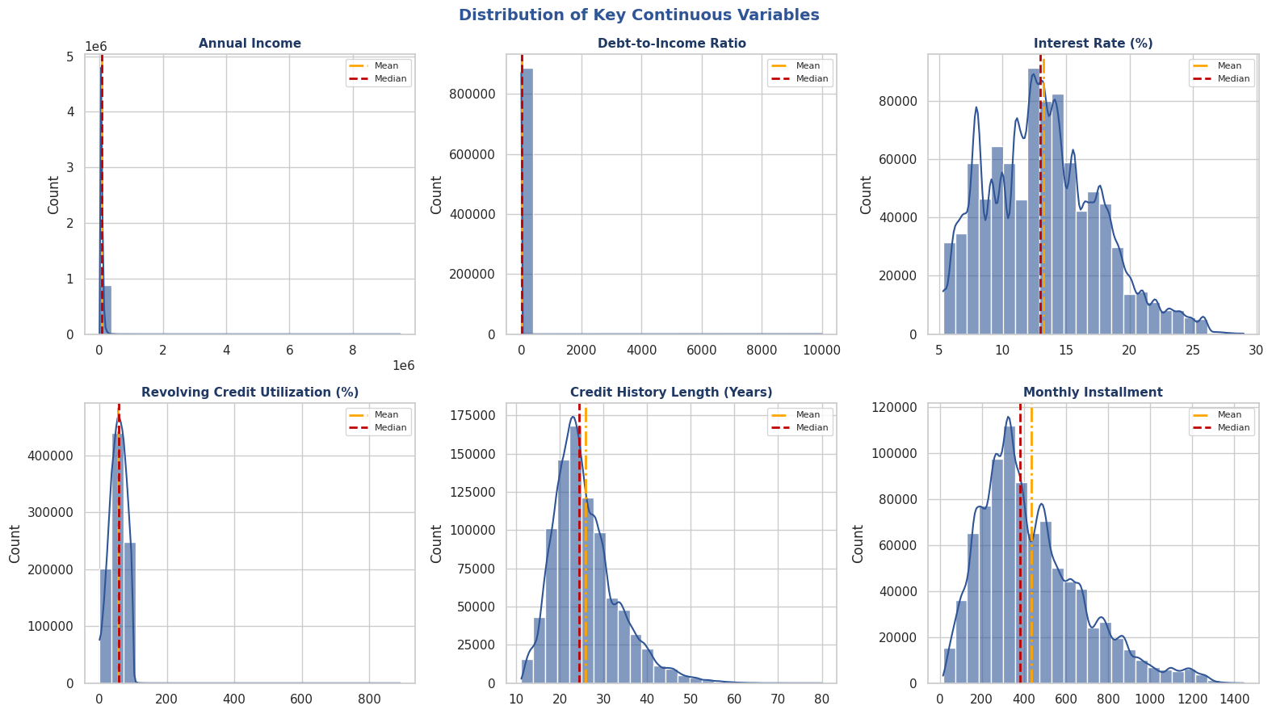
Analysis result
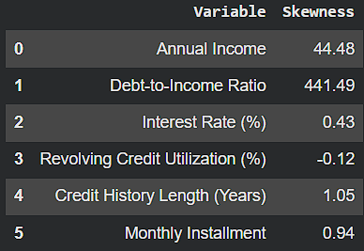
Key Findings
- Annual Income (44.48) and DTI (441.49) exhibit highly right-skewed distributions, indicating the presence of a small number of extreme borrowers. In the case of DTI the majority of borrowers are concentrated within a relatively narrow range, while a few extreme observations create a long right tail. This suggests that DTI should be analysed using bands rather than raw averages.
- Interest Rate and Revolving Credit Utilization are approximately symmetric and represent the portfolio well.
- Credit History Length and Monthly Instalment show moderate positive skewness, reflecting borrower diversity.
Actionable Insights
- Repayment improvement initiatives should focus on the large middle-income borrower segment rather than a small number of high-income customers, as they represent the majority of the portfolio.
- Borrowers with extremely high DTI values should be treated as high-risk candidates and prioritized for stricter underwriting or enhanced repayment monitoring.
- Interest Rate and Revolving Credit Utilization can be reliably used as portfolio-level monitoring KPIs and segmentation variables in management dashboards.
- The observed borrower heterogeneity supports a segmented lending strategy based on income, credit history, and repayment obligations rather than a one-size-fits-all approach.

Phase 5: Univariate Analysis – Categorical Variables
Understanding the distribution of these categories provides context for subsequent default and repayment analyses while highlighting segments with limited observations that require cautious interpretation.
Analysis result
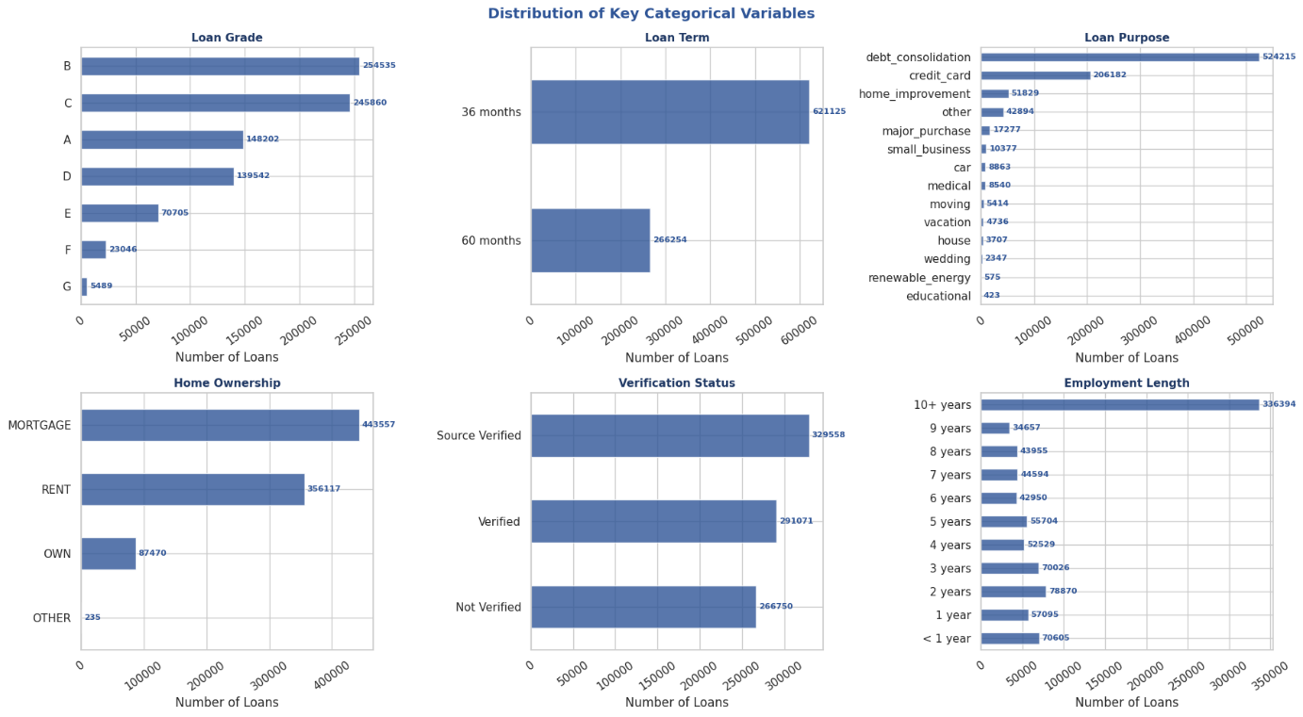
Key findings
- Grades B and C dominate the portfolio, while Grades F and G represent a very small share, requiring cautious interpretation in subsequent analyses.
- 36-month loans and debt consolidation purpose account for the majority of the loan book, making them the most influential portfolio segments.
- Mortgage and Rent borrowers constitute most of the portfolio, while Source Verified loans slightly outnumber other verification categories.
- “debt consolidation” purpose and borrowers with 10+ years employment length has significantly higher number of loans compared to others.
Actionable Insights
- Prioritize monitoring and repayment strategies for 36-month and debt consolidation loans, as improvements in these high-volume segments will have the greatest impact on overall LRR.
- Focus risk and default analysis on Grades A–D, where sufficient loan volume supports reliable business decisions, and validate findings for low-volume grades separately.
- Design borrower-specific strategies for Mortgage and Rent customers, as they represent the largest customer groups and offer the highest potential for improving portfolio performance.

Phase 6: Default Rate by Loan Characteristics
This phase evaluates the impact of loan characteristics on default risk. Default rates are analysed across loan grades, loan terms, and loan purposes to identify segments that contribute most to repayment risk and assess whether current pricing adequately reflects borrower risk.
Analysis result
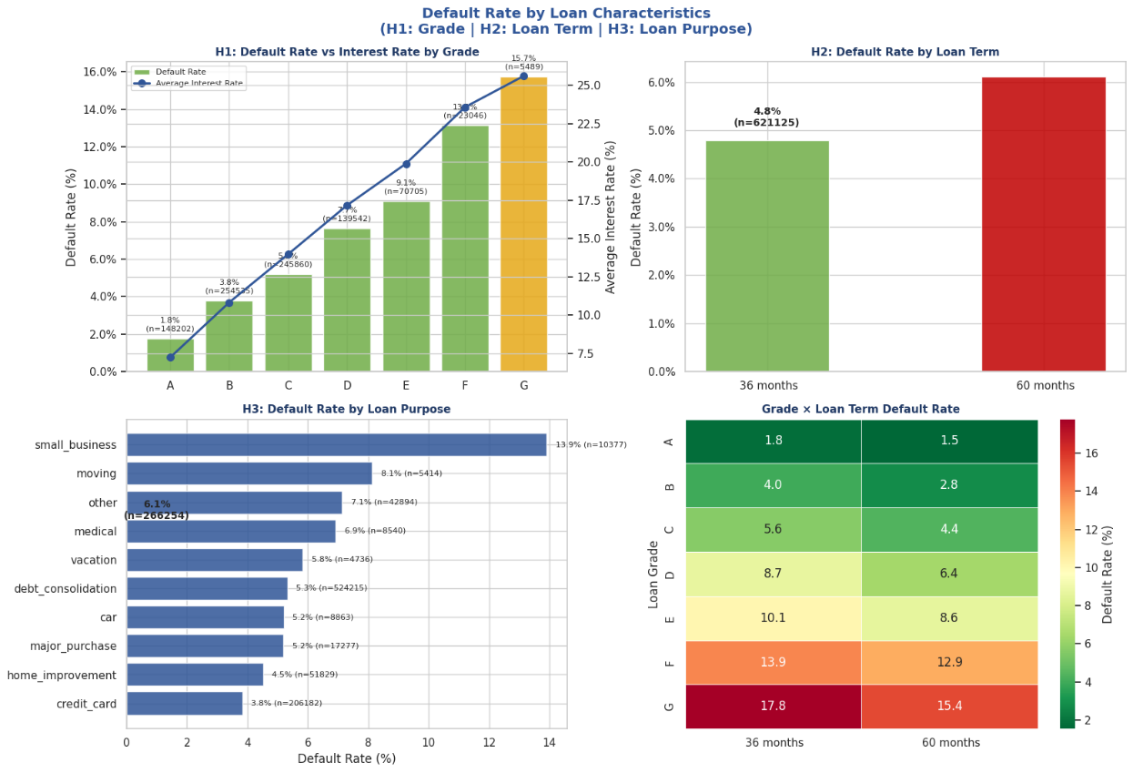
Key Findings
- Default rate increases consistently from Grade A (1.8%) to Grade G (15.7%), indicating that lower loan grades are associated with substantially higher credit risk.
- 60-month loans have a higher default rate (6.1%) than 36-month loans (4.8%), confirming the additional risk of longer repayment periods.
- Small Business and Moving loans exhibit the highest default rates, while Credit Card and Home Improvement loans show comparatively lower default risk.

Actionable Insights
- Strengthen underwriting and monitoring for lower-grade (E–G) borrowers, as they contribute disproportionately to portfolio default risk.
- Apply enhanced credit assessment for 60-month loans or introduce pricing strategies that better compensate for their higher default probability.
- Implement purpose-specific lending policies, with stricter approval criteria for Small Business and Moving loans while expanding lower-risk segments such as Credit Card refinancing.

Phase 7: Default Rate by Borrower Profile (H4, H5, H6)
This phase evaluates how borrower-specific characteristics influence default risk by analysing default rates across annual income bands, verification status, home ownership, and employment length.
The objective is to identify borrower segments that require targeted lending, monitoring, and risk management strategies to improve the overall Loan Repayment Rate (LRR).
Analysis result
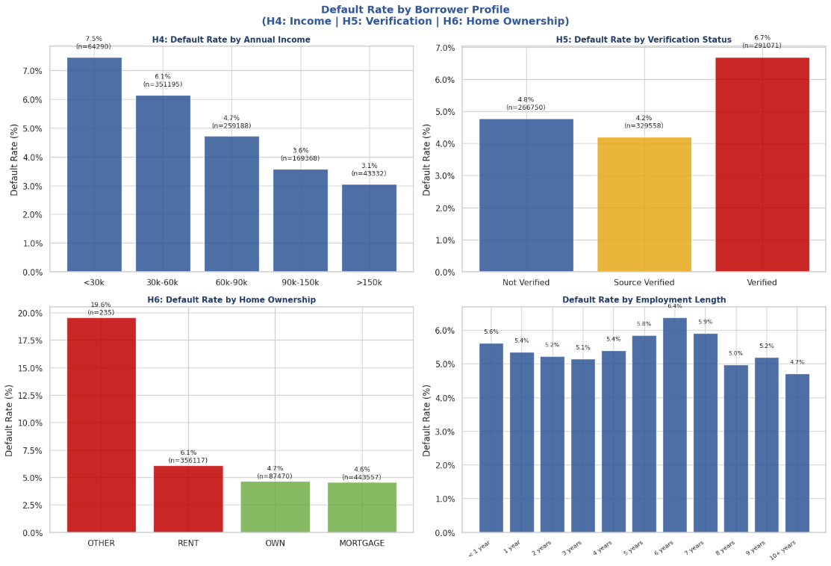
Key Findings
- Default rate decreases consistently as annual income increases, falling from 7.5% (<30k) to 3.1% (>150k), indicating lower-income borrowers carry higher repayment risk.
- Verified borrowers exhibit the highest default rate (6.7%), suggesting verification is applied selectively to riskier applicants rather than serving as a protective factor.
- Renters default more frequently than homeowners or mortgage holders (6.1% vs ~4.6%), while employment length shows only minor variation in default rates.
Actionable Insights
- Strengthen affordability checks and repayment support for lower-income borrowers, as they contribute disproportionately to default risk.
- Review the loan verification process, as higher defaults among verified borrowers indicate it functions as a risk-screening tool rather than a risk-reduction mechanism.
- Incorporate home ownership into credit assessment models, with additional monitoring for renter segments while treating employment length as a secondary risk indicator.
Although employment length is not part of the predefined hypotheses, it is included as an additional borrower stability indicator to identify whether longer employment tenure is associated with lower default risk.

Phase 8: Default Rate by Credit Behaviour (H7, H8, H9)
This evaluates whether borrower credit behaviour prior to loan approval influences the probability of default. By analysing debt burden, credit utilization, recent credit inquiries, and credit history length, we identify behavioural patterns that can improve underwriting decisions and portfolio risk management.
Analysis result
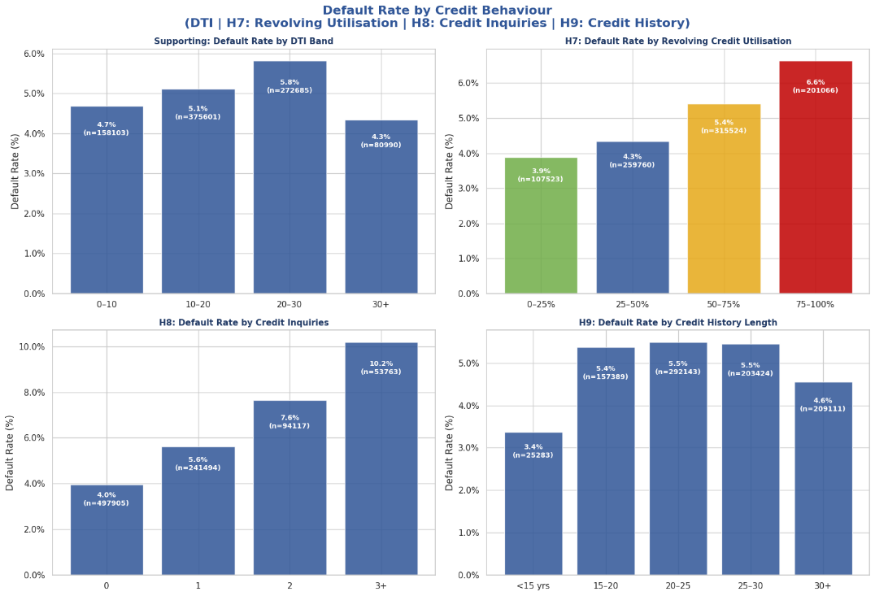
Key Findings
- Default rate increases steadily from 3.9% (0–25%) to 6.6% (75–100%), indicating that borrowers with higher revolving credit utilization are more likely to default.
- Default rate rises sharply with the number of recent credit inquiries, reaching 10.2% for borrowers with 3+ inquiries, making recent borrowing activity a strong indicator of credit risk.
- Borrowers with less than 15 years of credit history have the lowest default rate (3.4%), while the remaining groups show similar default rates (4.6–5.5%), suggesting credit history length alone is a relatively weak predictor.
- Default rate increases from 4.7% to 5.8% up to the 20–30 DTI band but declines for the 30+ group, indicating a non-linear relationship between debt burden and default risk.
Actionable Insights
- Incorporate revolving credit utilization and recent credit inquiries as high-priority underwriting variables, as both show a clear positive relationship with default risk.
- Apply additional review or risk-based pricing for borrowers with utilization above 50% or two or more recent credit inquiries to reduce future portfolio defaults.
- Use credit history length and DTI as supporting risk indicators rather than primary decision variables, since they exhibit comparatively weaker or non-monotonic relationships with default.

Phase 9: Loan Repayment Rate (LRR) by Portfolio Segments
This phase evaluates whether different borrower segments generate sufficient repayment relative to the amount funded. While previous phases focused on default risk, this analysis focuses on portfolio profitability, helping identify whether higher-risk loans are adequately compensated through repayments and interest income.
Analyisis result
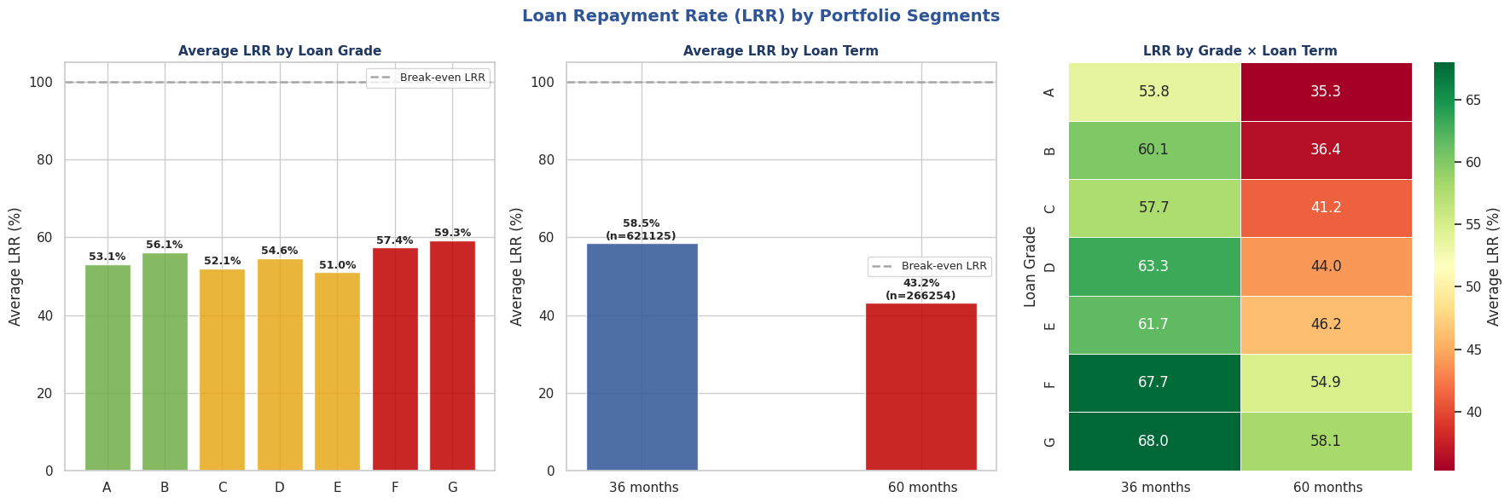
Key findings
- LRR varies across loan grades, with Grade G (68.0%) and Grade F (67.7%) achieving the highest repayment rates, while Grade E records the lowest (51.0%). This suggests higher-risk grades still generate relatively stronger repayments despite increased default risk.
- 36-month loans outperform 60-month loans, with an average LRR of 58.5% compared to 43.2%, indicating shorter loan terms recover a larger proportion of funded amounts.
- The Grade × Term heatmap shows that every grade achieves a higher LRR under the 36-month term, highlighting loan term as a key driver of repayment performance regardless of borrower grade.
Actionable insights
- Prioritize 36-month loans in future lending strategies, as they consistently deliver better repayment performance across all borrower grades.
- Review pricing and underwriting policies for 60-month loans, particularly in lower grades, to improve portfolio returns and reduce repayment shortfalls.
- Use the Grade × Term combination as a portfolio segmentation tool to identify high-performing segments and optimize future loan allocation decisions.

Phase 10: Interest Rate vs Loan Repayment Rate (LRR)
This phase evaluates whether loans with higher interest rates generate higher repayment performance by comparing the average Loan Repayment Rate (LRR) across different interest rate bands. Grouping loans into bands simplifies interpretation and helps assess the effectiveness of the bank's risk-based pricing strategy.
Analysis result
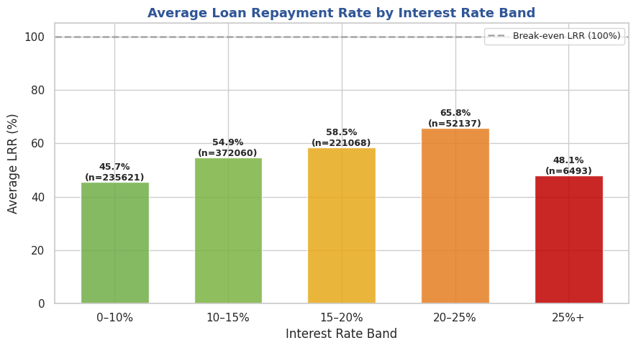

Key Findings
- Average Loan Repayment Rate (LRR) increases steadily from 45.7% to 65.8% as interest rates rise from 0–10% to 20–25%, indicating that moderate risk-based pricing improves portfolio repayment performance.
- The LRR drops sharply to 48.1% in the 25%+ interest rate band despite higher pricing, suggesting that the additional interest charged is insufficient to offset the elevated default risk in this segment.
Actionable Insights
- Maintain or optimize lending within the 15–25% interest rate range, where the portfolio achieves the strongest repayment performance and better risk-adjusted returns.
- Strengthen underwriting and borrower screening for loans priced above 25%, as increasing interest rates alone does not compensate for the higher credit risk and may reduce overall portfolio profitability.

Phase 11: Correlation Analysis of Key Numeric Variables
This phase evaluates whether different borrower segments generate sufficient repayment relative to the amount funded. While previous phases focused on default risk, this analysis focuses on portfolio profitability, helping identify whether higher-risk loans are adequately compensated through repayments and interest income.
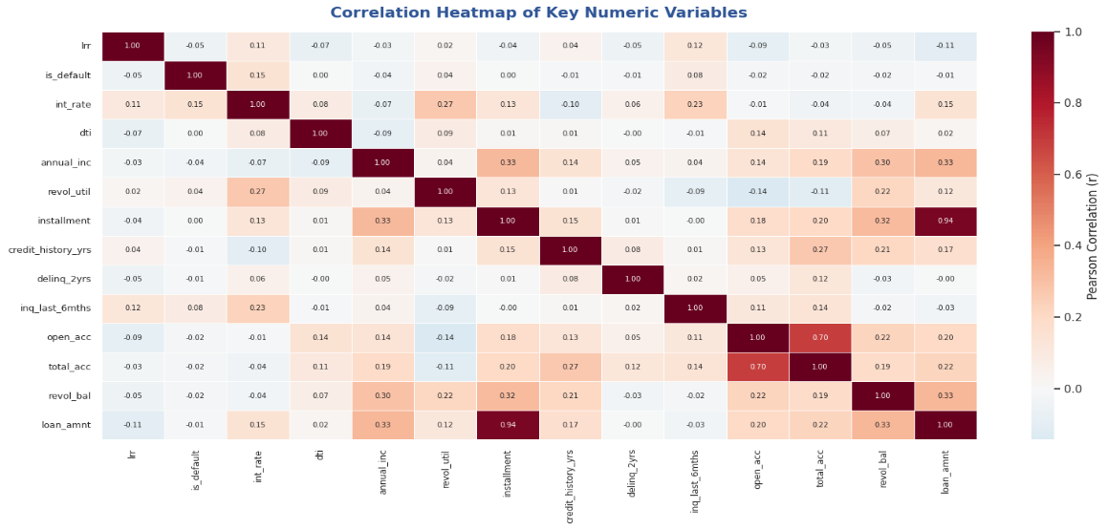
Analysis result
Key Findings
- Most variables exhibit weak correlations with both Loan Repayment Rate (LRR) and Default Rate, indicating that no single numerical feature independently explains loan performance.
- Interest Rate shows the strongest positive correlation with Default Rate (r = 0.15), suggesting higher-risk borrowers are generally assigned higher interest rates.
- Loan Amount and Installment are highly correlated (r = 0.94), while Open Accounts and Total Accounts also show strong correlation (r = 0.70), indicating these pairs capture similar information.
- LRR has only weak correlations with all variables (|r| ≤ 0.12), implying that repayment performance is influenced by a combination of borrower and loan characteristics rather than any single factor.
Actionable Insights
- Prioritize multi-factor risk assessment instead of relying on individual numerical variables, as default and repayment are driven by multiple interacting factors.
- Avoid using both Loan Amount and Installment together in dashboards or predictive models, since their strong correlation introduces redundant information without improving decision-making.

SUMMARY
The analysis revealed an overall Loan Repayment Rate of approximately 51.3% and a Default Rate of 5.2%, with Current and Fully Paid loans contributing the most to portfolio repayments. Loan Grades A–G showed a clear increase in default risk as credit quality declined, while 60-month loans consistently exhibited higher default rates than 36-month loans.
Borrower profile analysis indicated that lower-income borrowers, renters, and verified applicants experience relatively higher default rates. Similarly, borrowers with high revolving credit utilization and multiple recent credit inquiries demonstrated increased credit risk, making these variables valuable predictors for lending decisions. Correlation analysis further identified interest rate as the strongest numeric variable associated with default risk, while loan amount and installment were found to be highly correlated.
Portfolio profitability analysis showed that 15–25% interest rate bands achieved the highest Loan Repayment Rates, whereas loans priced above 25% experienced declining repayment performance, suggesting that higher pricing alone cannot compensate for elevated borrower risk.
Overall, the study identifies loan grade, loan term, borrower income, home ownership, revolving credit utilization, credit inquiries, and interest rate as the primary drivers of repayment performance and default risk. These insights provide a strong foundation for improving credit evaluation, pricing strategies, portfolio monitoring, and long-term profitability.

BUSINESS RECOMMENDATIONS
Based on the findings of this study, the following recommendations are proposed to improve loan portfolio performance and reduce credit risk:
- Strengthen underwriting for high-risk loan grades and long-term loans. Loan Grades E, F, and G, along with 60-month loans, consistently exhibit higher default rates and should undergo stricter credit evaluation before approval.
- Prioritize borrowers with stronger financial profiles. Higher-income applicants and borrowers with stable home ownership (OWN or MORTGAGE) demonstrate lower default rates and should receive favourable consideration during loan approval
- Incorporate credit behaviour into risk assessment models. High revolving credit utilization and multiple recent credit inquiries are associated with increased default risk and should be assigned greater importance in underwriting decisions.
- Optimize risk-based pricing strategies. Loans priced between 15% and 25% interest rates generate the highest average Loan Repayment Rates, while loans above 25% show declining repayment performance. Pricing decisions should therefore be combined with stronger borrower screening rather than relying solely on higher interest rates to offset risk.
- Focus portfolio monitoring on dominant business segments. Since the majority of the portfolio consists of Grades B/C, 36-month loans, and Debt Consolidation purposes, even small improvements in these segments can produce significant gains in overall portfolio performance.
- Develop predictive risk dashboards for continuous monitoring. Variables such as loan grade, interest rate, borrower income, home ownership, revolving utilization, and credit inquiries should be integrated into business intelligence dashboards to enable early identification of high-risk borrowers and support proactive collection strategies.
By implementing these recommendations, UCUCI Bank can improve repayment performance, reduce default exposure, optimize pricing decisions, and enhance the overall profitability and sustainability of its loan portfolio.

